**Learner’s Space: Python for Data Science**

**ASSIGNMENT_Week 1**

Hello, we hope you had a good time watching the tutorials for the course and have learned a lot from them. Let’s try out the following questions!

1. Create and print a 2-dimensional NumPy array of shape (5, 5) filled with random* integers between 1 and 100. Perform the following tasks:
   1. Extract and print the middle element of the array using NumPy indexing.
   2. Calculate and print the mean of each row of the array.
   3. Create a new array that contains only the elements from the original array that are greater than the overall mean of the array.
   4. Write a Python function numpy_spiral_order(matrix) that takes a NumPy matrix and returns a list containing the elements visited in a spiral order.

Example: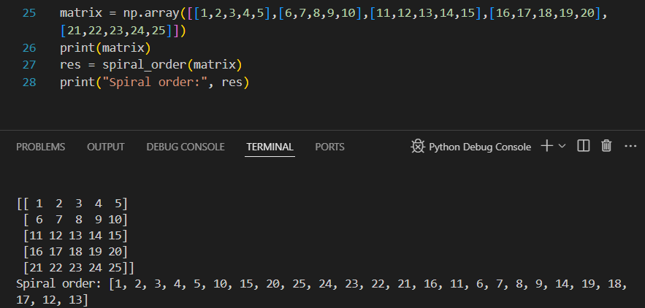

**Hints:**

* Use np.random.randint() to create the initial array arr.
* Use NumPy functions like np.mean() and boolean indexing to perform calculations and extract elements.

**Now let’s try to apply Python libraries on a dataset of Video Game Sales!**

1. Create a Jupyter Notebook or a Google Colab Notebook, download the dataset in the drive link, and solve the following questions using the required Python libraries:
   1. Add a column of ‘global_sales’ showing the total sales of all the different regions to the data frame and sort (highest first) and print the DataFrame according to it.
   2. Display a plot of the total number of copies sold of each genre globally.
   3. Filter out only the games containing ‘Grand Theft Auto’ in their name and display the following as a DataFrame :
      1. their name
      2. the platform they were released on
      3. the year they were released in
      4. the sum of sales in only Europe and Japan
   4. Display a pie chart of the total sales of all Grand Theft Auto games combined in North America, Europe, Japan, and other sales.